|  |  |  |  |
| --- | --- | --- | --- |
| 1 | | 2,868.0 | |
| NUMERO DE FRONTERAS | | ENERGIA AGREGADA | |
|  | | | |
| SI | | 02/01/2022 | |
| CONTRATO | | VENCIMIENTO CONTRATO | |
|  | | | |
| 7,928,572 | 60 | | 283,090 |
| INGRESO 2020 | DÍAS CERTIFICADOS 2020 | | ENERGIA RESPALDADA 2020 |
|  | | | |
| 964,916 | 14 | | 39,978 |
| INGRESO 2021 | DÍAS CERTIFICADOS 2021 | | ENERGIA RESPALDADA 2021 |

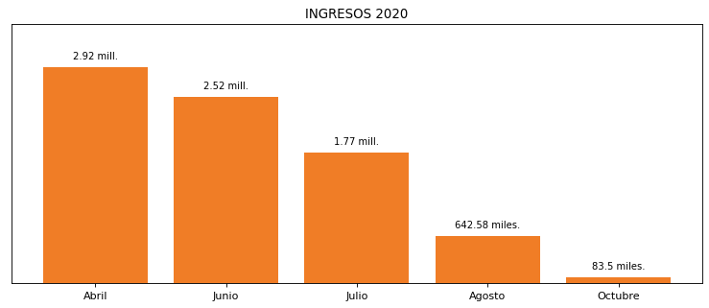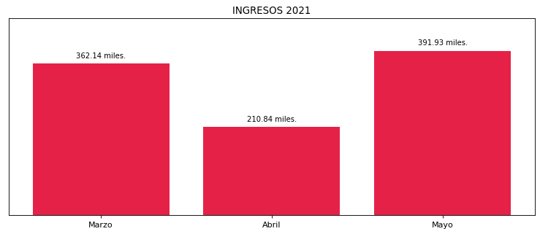

|  |
| --- |
| **HOTEL EL DORADO**  USUARIO |

|  |
| --- |
| **Edwin Torres**  Ejecutivo de cuenta |

|  |
| --- |
| **William Monroy / Gerente General / 0**  PUNTO FOCAL |

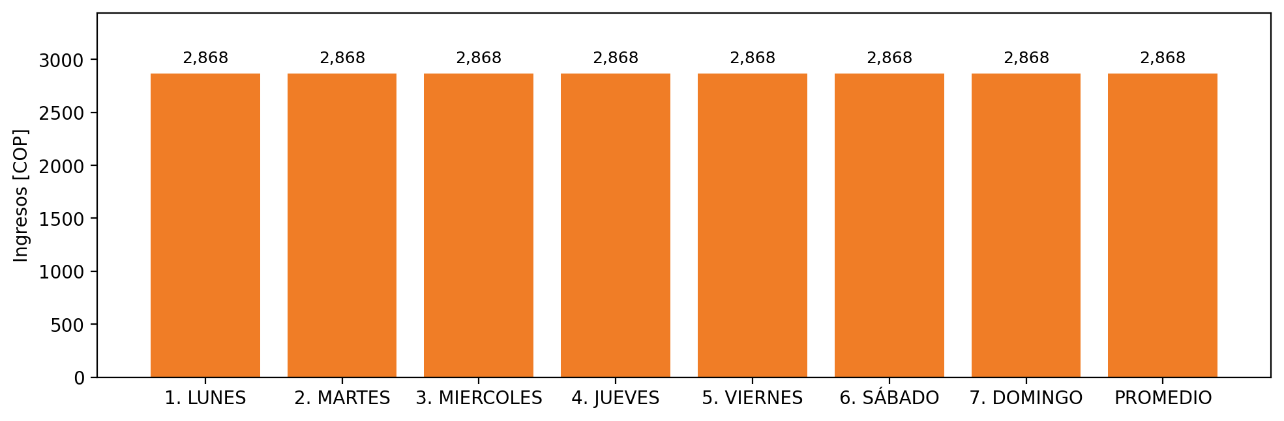

|  |  |  |  |  |  |  |  |  |  |  |
| --- | --- | --- | --- | --- | --- | --- | --- | --- | --- | --- |
| **FRONTERA** | **COD SIC** | **PREDIO** | **FRT DDV** | **TIPO DDV** | **PROMEDIO** | **PRÓXIMA ACTUALIZACIÓN** | **MARGEN DE ERROR** | **ÚLTIMA PRUEBA DDV** | **DÍAS PARTICIPACIÓN** | **FECHA REFERENCIA PRÓXIMA PRUEBA DDV** |
| HOTEL EL DORADO | Frt00827 | Prd01512 | Frt35877 | LBC | 2,868 | 2022-03-02 | 4,29 | 2020-04-03 | 74.0 | 2021-12-05 |